CITY OF EAST MOUNTAIN

Chapter 4 Article I

SPEED LIMIT WITH IN THE CITY LIMITS

Article I- Speed Limit With-in the City Limits

Sections

4:01 Maximum limits generally

4:02 Maximum limits on specific streets

4:03 Speed limit signs

4:04 Effective Date

**City of East Mountain Chapter 4 Article** I

**Speed Limits with in the City Limits**

**Article I**

**Speed Limits within City Limits**

**Sec. 4.01 - Maximum limits generally.**

1. No person shall operate or drive any vehicle on any street within the city at a greater speed than thirty (30) miles per hour, except as otherwise specifically provided in this article.
2. Notwithstanding any other provisions of this article, no person shall drive a vehicle on a street at a speed greater than is reasonable and prudent under the conditions and having regard to the actual and potential hazards then existing. In every event, speed shall be so controlled as may be necessary to avoid colliding with any person, vehicle or other conveyance on or entering the street in compliance with legal requirements and the duty of all persons to use due care.
3. The driver of every vehicle shall, consistent with the requirements of paragraph (b), drive at an appropriate reduced speed when approaching and crossing an intersection or, when approaching and going around a curve, when approaching a hillcrest, when traveling upon any narrow or winding roadway, and when special hazard exists with respect to pedestrians or other traffic or by reason of weather or highway conditions.

**Sec. 4.02. - Maximum limits on specific streets.**

1. Streets designated. The following prima facie maximum speed limits indicated in this section for motor vehicles are hereby determined and declared to be reasonable and safe, and such maximum speed limits are hereby fixed at the rate of speed indicated for motor vehicles traveling upon the named street or highway, or parts thereof, and no motor vehicle shall be operated along or upon such portions of such named street or highway within the corporate limits of the City of East Mountain in excess of the speeds now set forth in the following limits:

FM 3358 from the HWY 300 cut off north to the north City Limits 55 MPH.

FM 726 from the east City Limit Sign, across HWY 300 to the west City Limits 55 MPH.

Medlin Road from the intersection of FM 726 to the intersection on Main St. 40 MPH.

Main St. (FM 1845) from the north City Limit to the south City Limit 55 MPH excluding the 40 MPH zone from the intersection on Medlin Rd south to the intersection of FM 1844.

Pheasant Rd from FM 1845 to the west City Limit 20 MPH Meadow Drive from Pheasant to Mountain View Rd 20 MPH Carrie Dr from the intersection of FM 1845 to the end 20 MPH

Mountain View Rd from the intersection of Meadow Dr to the intersection of FM 1845 20 MPH Circle Ridge Dr from the intersection of Main St back to the opposite intersection of Main St 20 MPH East Mountain Dr North from the intersection of Main St to the intersection of 1844 20 MPH Municipal Dr from the west City Limits to the intersection of East Mountain Dr North 20 MPH

East Mountain Dr South from the intersection of FM 1844 to the south City Limits 40 MPH Turkey Rd from FM 1844 to the south City Limits 25 MPH

Beall Mountain Rd from the intersection of East Mountain Rd South to the south City Limits 20 MPH Yellow Throat Rd from Beall Mountain to the intersection of East Mountain Rd South 20 MPH

FM 1845 from the intersection of FM 1844 to the south City Limits 55 MPH

FM 1844 from the intersection of FM 1845 to the intersection of HWY 300 55 MPH HWY 300 in its entirety to me set by the State of Texas.

**Sec. 4.03 - Speed limit signs.**

Whenever this article or any other ordinance of the city modifies and alters the basic speed limit established in section 1.02, the City of East Mountain shall cause signs to be posted at the several locations giving notice thereof and no such modification and alteration shall be effective unless such signs are in place.

**Sec. 4.04 Effective date.**

This subchapter shall take effect from and after its publication one time in the official publication of the city, which publication shall contain the caption, stating in summary the purpose of this subchapter and the penalty for violations thereof.

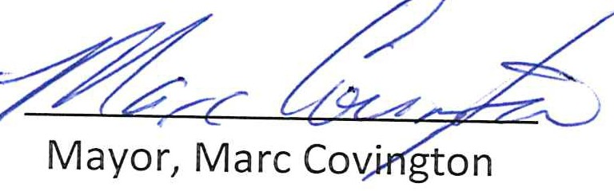This ordinance has been approved by majority vote of the Council on September 12, 2022, City of East Mountain, Texas

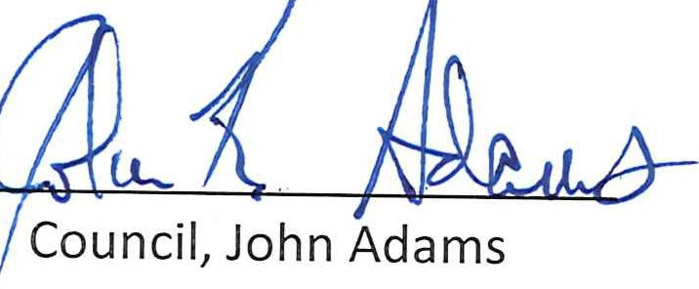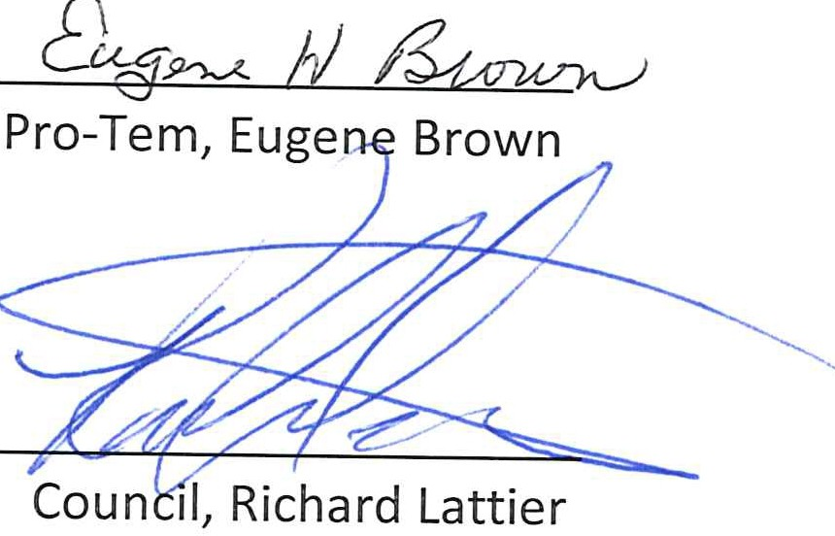Council, Billy Morrow

iJ7

Council, Danny Medlin

City Secretary, Lisa Stewart