**CITY OF** ..._

EAST MOUNTAIN

**IN GOD WE TRUST" SINCE 1978**

Proposed Amendment to Ordinance# 87

# WATER METER PROCEDURE

1. PULL METER AFTER 2 MONTHS DORMANT.
2. METER PULLED FOR NO SERVICE MORE THAN 6 MONTHS AND SERVICE ON MAIN LINE IS OLDER THAN 15 YRS OLD

REQUIRED TO PAY FOR TAP AND METER...$2365.00 IF BORE REQUIRED ADDL' $1500.00

1. OLD LINE LESS THAN 15YRS OLD DOES NOT HAVE TO BE REPLACED.

**(DOES NOT EFFECT CURRENT ACTIVE ACCOUNTS ONLY NON EXISTING OR OLD ACCOUNTS)**

1. 1" METER REQUIRED WHEN SUPPLYING 10-RV'S
2. TINY HOME, DUPLEXES, HOUSES, MOBIL HOMES- METER PER ENTRANCE DOOR
3. ADDED SHOP TO RESIDENT WITH ONLY A RESTROOM CAN ATTACH TO THEIR METER
4. ADDED SHOP TO RESIDENT WITH LIVING QUARTERS MUST ADD ITS OWN METER

# lN!RODUCTION•:

CITY OF EAST MOUNTAIN

103 MUNICIPAL DRIVE

GIT.MER, TX 75644

**CITY ORDINANCE #87**

AMENDED and APPROVED April 9, 2018

The City _of East lVIountain provides drinking water to the

residents of the City of East Mountain and surrounding areas through the East Mountain Water Supply System, and is responsible for protecting the system's drinking water fro1n contamination or pollution, which could result fr01n improper plumbing practices.

1. **PURPOSE:** The purpose of this ordinance is to institute a process to inform a new customer to the East Mountain vVater Supply System of restrictions that are in place to provide this protection.

Furthermore, in order to ensure that the public health and welfare are not c01npromised, East Mountain Water Utility Syste1n assumes any and all righti; and privileges that the system administrators deem necessary to enforce these restrictions. Each new custmner to the East Mountain Water Syste1n 1nust sign a copy of this agreement with the City of :a.st Mountain Water System, prior to commence1nent of service.

In addition, if the water service to an existing connection has been suspended or terminated, for whatever reason, the Water Supply System reserves the right to not re-establish said service unless it has a signed copy of this agreement.

1. **PLUMBING RESTRICTIONS:** The Following are plumbing practices which are prohibited by the State of Texas and the United State of Gove ment:
   1. A new water service will not be installed (a new tap 011 uudevclopcd property or an existing tap on undeveloped property) unless the properly has been inspected and approved, meetiug all local, county and slate requirements concerning waste waler disposal for the structure t<> be built or moved on to said properly.
   2. A direct connection between the public drinking water supply and any potential source of contamination is prohibited. Furthe1more, any potential source of contamination to the water supply system will be isolated from public water system by an air gap of at least 3 inches in distance, or a back.How prevention device of a type which has been accepted and approved by the American Water Works A'lsociation for use in public water supply service. •
2. A cross-conn cl.ion betw en lhc p blic water supply service and any privately owned wa e system 1s o permitted. This potential threat to the quality of public diinking watc1 shall be c!munatcd at the service connection by lhe installation of an air gap at

least 3 (tlu·ce) mches in length or by the installation of a reduced pressure zone backflow prevention device.

1. Any connection which allows water to be returned to the public drinking water supply is prohibited.
2. No pipe or pipe fitting which contains more than 8.0% (eight percent) lead will be used as a component for the installation or repair of any plumbing which is used to provide water for human consumption.
3. Solder or flux containing more than 0.2% lead will not be used for the installation or repair of any plumbing at a service, •which is used to provide water for human consumption.
4. **SERVICE AGREEMENT:** The following are the terms of the service agreement between the East Mountain Water Syste1n and the new water customer:
   1. The water system will be responsible for the maintenance of a properly signed copy of this agTecment, so long as the afore-named customer is connected to the :ast Mountain Water Supply System.
   2. The customer shall allow his property to be inspected for any possible cross-connection or undesirable plumbing practices at that location. This inspection shall be conducted by an official of the Water System, or its designated agent, prior to initiating service and periodically thereafter. 'These inspections shall be conducted during the Water System's normal business hours.
   3. The Water System shall notify the customer in writing of any undesirable plumbing practices which have been identified during the initial inspcctie>n <>r the periodic re.:. inspection. The customer, at his or her own expense, shall immediately c<>rrccl any undesirable plumbing practices which have been detected on his premises.
   4. The customer shall, at his own expense, install, test and properly maintain any back llow prevention device required by the Water System. Copies of testing and maintenance records shall be provided to the Watcr System.
   5. Check valves will be installed for all new water customers.
5. **ENFORCEMENT:** In the event tl1at a vVater Supply Syste1n cust01ner fails to cmnply with the tenns and conditions of this service agree1nent, the East Mountain Water Syste1n shall, at its own discretion, and ivith due notification to the cust01ner, . terminate all water service to this location, 0 R properly install and test any equip1nent or devices clee1ned necessary to bring this service connection into compliance with this service agreement, and any and all other State of Texas or United States Govern1nent requirements, as mandated in the Safe Drinking Water Act of 1976. Any and all expenses associated with providing this service will be the responsibility of the cust01ner. •

The customer shall further be advised that pay1nent is due on the 5'11 day of each month. If the *5th*day of the 1nonth ·falls on a weekend or a holiday, the payment is

clue by *5:00* **P.M.** on the following business day. A late foe of $15.00 will be assessed if the pay111ent is not received by *5:00* **P.M.** on the due date. If service is disconnected due to non-pay1nent, a *$50.00* re-connect fee will be added. If an illegal re-connect has been 1nade after service has been disconnected (cutting lock., etc.), a foe of *$352.00* will be assessed.

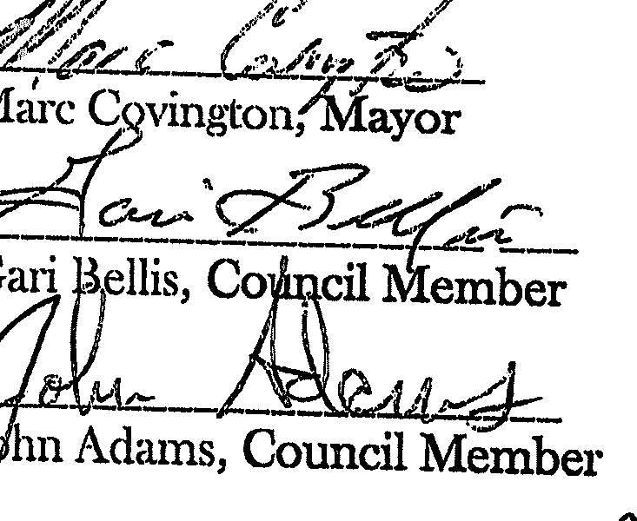Passed for ainenchnent, re-approval by n1ajority vote this 26d• day of March, 2018.

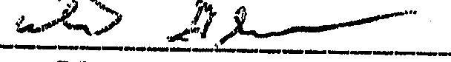

Lester Glover, Council Member

*{] '?_!}_-_* ?1M4i

Charles Medlin, Council Member

\.

Billy Morrow, Council Member

Subscribed and attested: - •-,'il-----

Robin R. Gray, City s«cretary