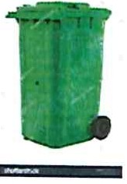CITY OF EAST MOUNTAIN

**103 MUNICIPAL DR.**

**GILMER, TX 75645**

**903-297-6041**

**APPLICATION FOR TRASH SERVICE**

NAME: _ PHONE--

MAILING ADDRESS:

SERVICE ADDRESS: COUNTY (U/G): _

E-MAIL: DL# _ IS RESIDENCE INSIDE CITY LIMITS? YES or NO

Rates:

Inside City Limits Outside City Limits Extra Container

$23.00 + Tax

$29.00 + Tax

$11.00 + Tax

PROPERTY: OWNER or RENTER

IF YOU ARE RENTING, PLEASE COMPLETE THE FOLLOWING:

Name of Property Owner (If different from above): _

ADDRESS: _

PHONE:

Signature: Date: _

**For Office Use Only**

Date:

Acct# _ Rate Code: Route: _